**Acidity Constants**

Hydrolysis Reaction:

“A reaction where bonds are broken using water”

* The strength of an acid or base is described in terms of the position of the equilibrium produced when the substance reacts with water. This reaction is a hydrolysis **reaction**.

**Acidity Dissociation Constant (Acidity Constant)**

* The **equilibrium constant** for an acid hydrolysis reaction is referred to as the **acidity constant** and represented by the symbol **Ka**
* It is a measure of how easily an acid **donates** a proton to water

Example:



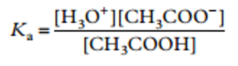

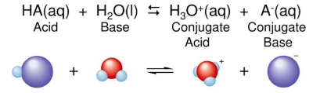General Equation

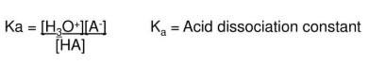

* The acidity constants for common acids are shown in the table below:

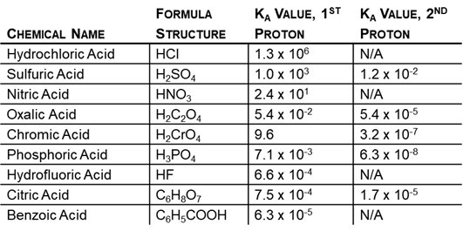

**Successive Ionisation**

* The above table shows that for polyprotic acids (e.g. H2SO4) each successive ionisation occurs to a lesser degree [e.g. HSO4-(aq) is a weaker acid than H2SO4(aq)]

For example:

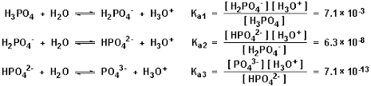Phosphoric acid is a triprotic acid, with each successive ionisation occurring to a lesser degree than the previous, indicated by successively smaller acidity constants.